INTERNSHIP REPORT

On

**WEBSITE DEVELOPMENT FOR SARATHI SYSTECH PVT LTD**

By

Shashank Birajdar (TECOMP-B03)

Under the guidance of

Prof. Minal Bodke

**Department of Computer Engineering**

## Pimpri Chinchwad College of Engineering and Research, Ravet Plot No: B, Sector No. 110, gate no 1, Laxmi Nagar, Ravet, Pune, Pin.: 412101

**Savitribai Phule Pune University [2022-2023]**

**PIMPRI CHINCHWAD EDUCATION TRUST’S**

# Pimpri Chinchwad College of

**Engineering and Research, Pune 412101**



# CERTIFICATE

This is to certify that the seminar report entitled

“**WEBSITE DEVELOPMENT FOR SARATHI SYSTECH PVT LTD**”

Submitted by

Shashank Birajdar (TECOMP-B03) have successfully completed the Internship seminar presentation entitled **“*Website development for Sarathi systech services Pvt Ltd*”** in the fulfillment of TE (Computer Engineering) and this work has been carried out in my presence.

**Date: 26/04/2023**

**Place: Ravet**

|  |  |  |
| --- | --- | --- |
| **Mrs. MinalBodke** | **Dr. Archana Chaugule** | **Dr. Tiwari H.U.** |
| **Internship Co-Ordinator** | **HOD, Computer Department** | **Principal, PCCOE&R** |

**ACKNOWLEDGEMENT**

It gives me great pleasure to present Seminar on **“*Website development for Sarathi systech services Pvt Ltd”*.** In preparing this report, a few hands helped me directly and indirectly. Therefore, it becomes my duty to express my gratitude towards them.

I am very much obliged to the internship coordinator ***Mrs. Minal Bodke,*** in the Computer Engineering Department, for helping me and giving me proper guidance. I will fail in my duty if I don't acknowledge a great sense of gratitude to the Head of Department ***Dr. Archana Chaugule*** and the entire staff members for their cooperation.

I am also thankful to my family for their wholehearted blessings are always for me support and constant encouragement towards the fulfillment of the work. I wish to record the help extended to be my friends in all possible ways and active support and constant encouragement.

**Place: Ravet, Pune. Shashank Birajdar**

**Date: 23/04/2023 TECOMP-B03**

**TABLE OF CONTENTS**

### Chapter 1: Introduction

* 1. Introduction
  2. Company Details
  3. Problem Statement
  4. Objectives

### Chapter 2: Methodology/ Proposed System

* 1. Proposed system architecture/framework
  2. Algorithms

### Chapter 3: Hardware and Software Requirements

* 1. Front Technology
  2. Backend Technology
  3. Hardware

### Chapter 4: Result and Conclusion

* + 1. Result (Screenshots of the projects in color print)
    2. Conclusion
    3. Future Scope
    4. References

**Chapter 5: Internship Completion Letter**

**LIST OF FIGURES:**

|  |  |  |
| --- | --- | --- |
| **Figure. No.** | **Title** | **Page No.** |
| 1 | Methodology and proposed model | 9 |
| 2 | Implemented website screenshot 1 | 11 |
| 3 | Implemented website screenshot 2 | 11 |
| 4 | Implemented website screenshot 3 | 12 |
| 5 | Implemented website screenshot 4 | 12 |
| 6 | Database implementation screenshot | 13 |

**CHAPTER 1: INTRODUCTION**

* 1. **Introduction:**

Welcome to our website, where we provide a platform for buyers and providers to connect and transact seamlessly. We understand that finding the right products or services can be a daunting task, and that's why we've created a third-party medium that simplifies the process for both parties. As a buyer, you can easily browse through our wide selection of products and services, compare prices and features, and make informed decisions. Our platform also allows you to communicate directly with the providers, ask questions, and negotiate deals. We ensure that all providers on our platform are vetted and meet our quality standards, so you can have peace of mind knowing that you're working with trustworthy and reliable partners. As a provider, you can leverage our platform to showcase your products or services to a wider audience, increase your visibility, and generate more leads. You can also manage your orders, track your sales, and receive payments securely through our platform. We strive to create a level playing field for all providers, regardless of their size or location, so that everyone has an equal opportunity to succeed. At our website, we are committed to providing a transparent and efficient marketplace for buyers and providers. We believe that by creating a mutually beneficial environment, we can help businesses grow and thrive. Join us today and discover the endless possibilities of our platform.

**1.2 Company Details:**

Name of company: Sarathi Systech Services PVT LTD.

Contact details:

Phone No.: 020-65800007

Mob: +91 9860 11 6402, 9011 48 8935

Start and end date: 1/2/23 to 1/3/23

Stipend: None

Internship mode: Online

* 1. **Problem Statement:**

To design and develop a website for company to showcase their services, in general providing a medium for customer to interact and describe the requirement.

* 1. **Objectives:**

1. Enhance online presence: A well-designed and functional website can help increase the visibility of the company and its services online. It can also provide a platform to showcase the company's unique offerings and competitive advantages.

2. Improve customer experience: A user-friendly website that is easy to navigate can improve the customer experience and increase customer satisfaction. It can also provide customers with the information they need to make informed decisions about the company's services.

3. Generate leads: A website that is optimized for search engines and provides valuable information can attract potential customers and generate leads for the company. It can also provide a platform for customers to contact the company and inquire about its services.

4. Increase sales: A website that is designed to convert visitors into customers can increase sales for the company. It can provide customers with the information they need to make purchasing decisions and facilitate the sales process.

5. To eliminate physical and logistical experience such as repetitive contact on calls and recursive meetings which will save time.

## CHAPTER 2: METHODOLOGY/ PROPOSED SYSTEM

1. Registration: The buyer and provider both register on the website, providing necessary details such as name, contact information, and business details. The registration process may include verification of identity and validation of business information.

2. Communication: The buyer communicates with the provider through the website, asking any necessary questions or inquiring about the details of the product or service. The website may include messaging, chat, or email functionalities to facilitate communication between the buyer and provider.

3. Negotiation: The buyer and provider negotiate the terms of the transaction, including price, quantity, delivery, and payment method. The website may include tools to facilitate negotiation, such as offer submission, counteroffer, and acceptance.

4. Purchase and Payment: Once the buyer and provider agree on the terms of the transaction, the buyer makes the purchase and submits payment through the website. The website may support various payment methods, such as credit card, PayPal, or bank transfer.

5. Delivery and Fulfillment: The provider delivers the product or service to the buyer according to the agreed-upon terms. The website may include tools to track delivery status and confirm receipt of the product or service.

6. Feedback and Ratings: After the transaction is completed, both the buyer and provider may provide feedback and ratings on the website. This feedback and rating system can help build trust and credibility for future transactions on the website.

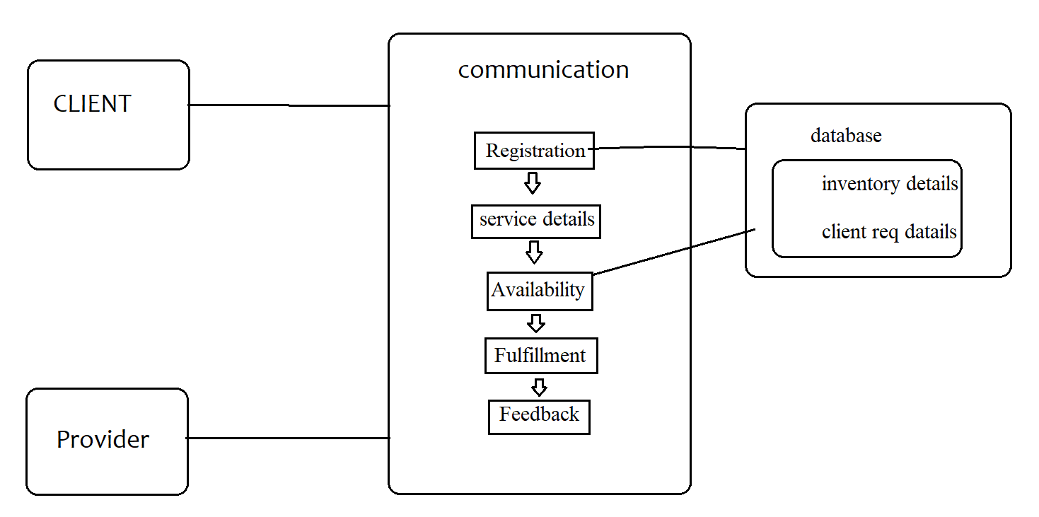

Figure 1:Methodology or proposed system

### Chapter 3: Hardware and Software Requirements

**3.1 Hardware Requirements:**

1. Processor: A multicore processor with a clock speed of at least 2GHz is recommended for web development and backend database work.

2. RAM: At least 8GB of RAM is recommended for web development and backend database work.

3. Storage: A solid-state drive (SSD) with at least 256GB of storage is recommended for web development and backend database work.

4. Graphics: A dedicated graphics card is not necessary for web development and backend database work.

**3.2 Software Requirements:**

1. Text Editor: A text editor such as Visual Studio Code, Sublime Text, or Atom is recommended for web development.

2. Web Browser: A web browser such as Google Chrome, Mozilla Firefox, or Safari is required for testing web applications.

3. Web Development Framework: Depending on the programming language being used, a web development framework such as Node.js, Ruby on Rails, or Django may be required.

4. Database Software: For backend database development, a database software such as MySQL, PostgreSQL, or MongoDB may be required.

5. Version Control: A version control system such as Git is recommended for managing code changes and collaboration.

**CHAPTER 4: Result and Conclusion**

**4.1 Result:**

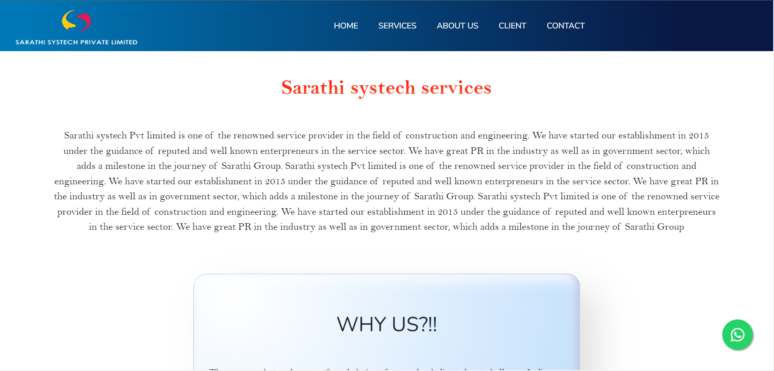 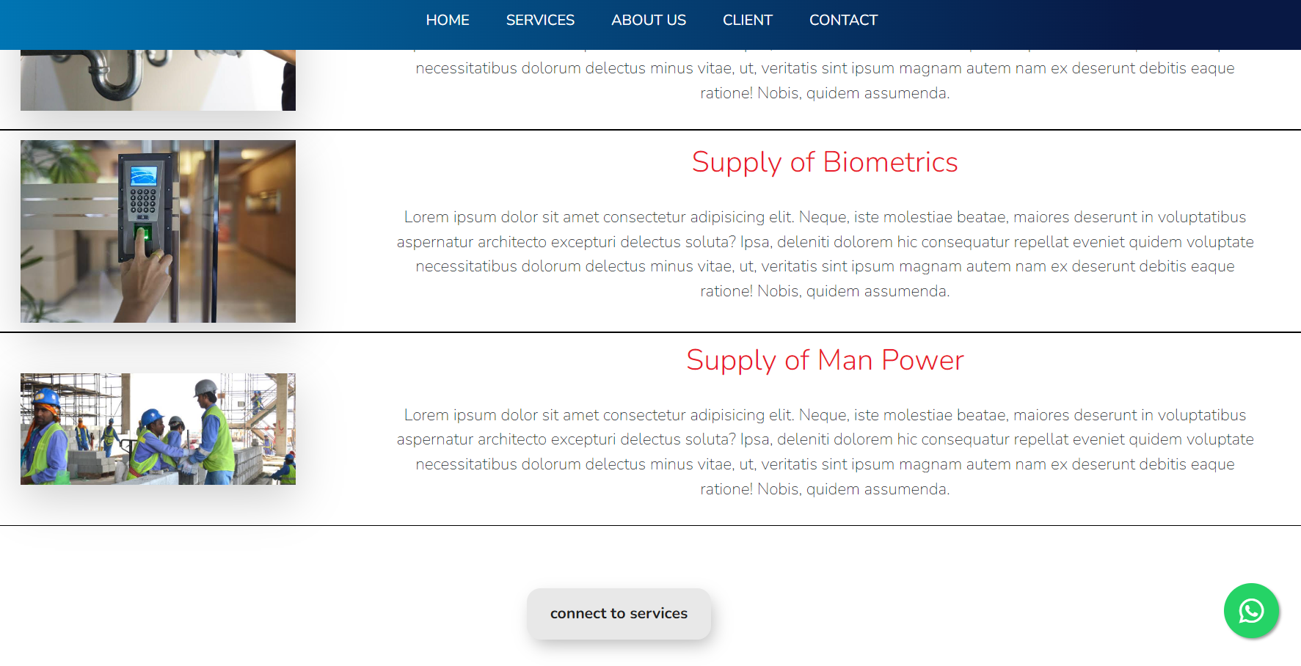 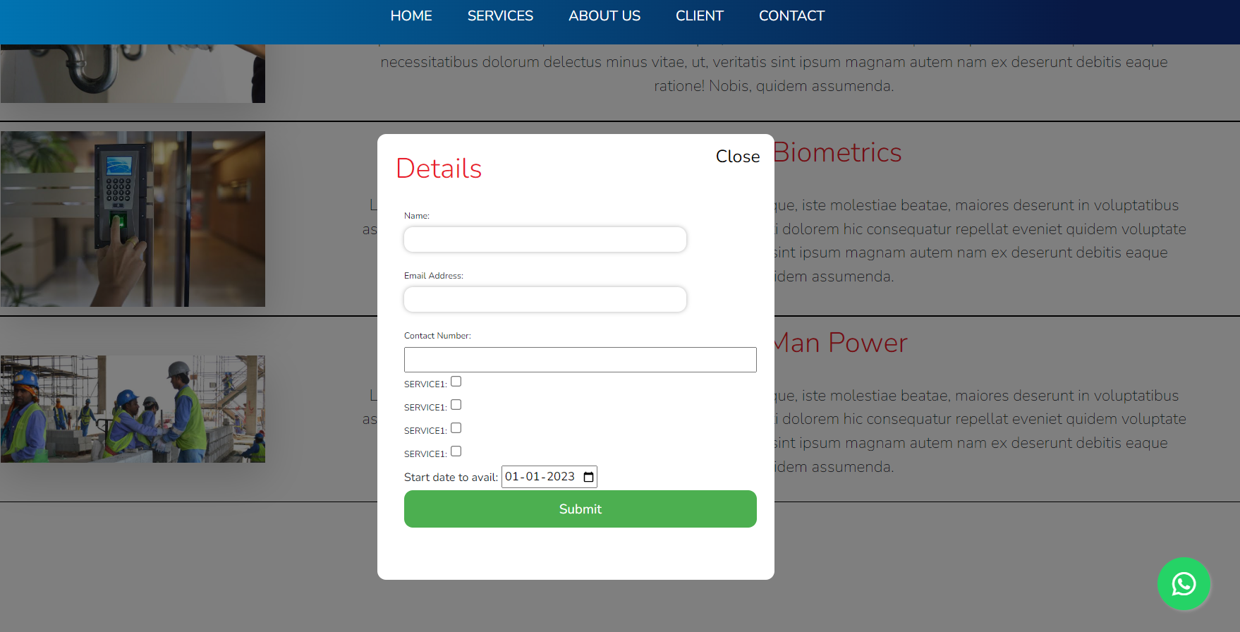

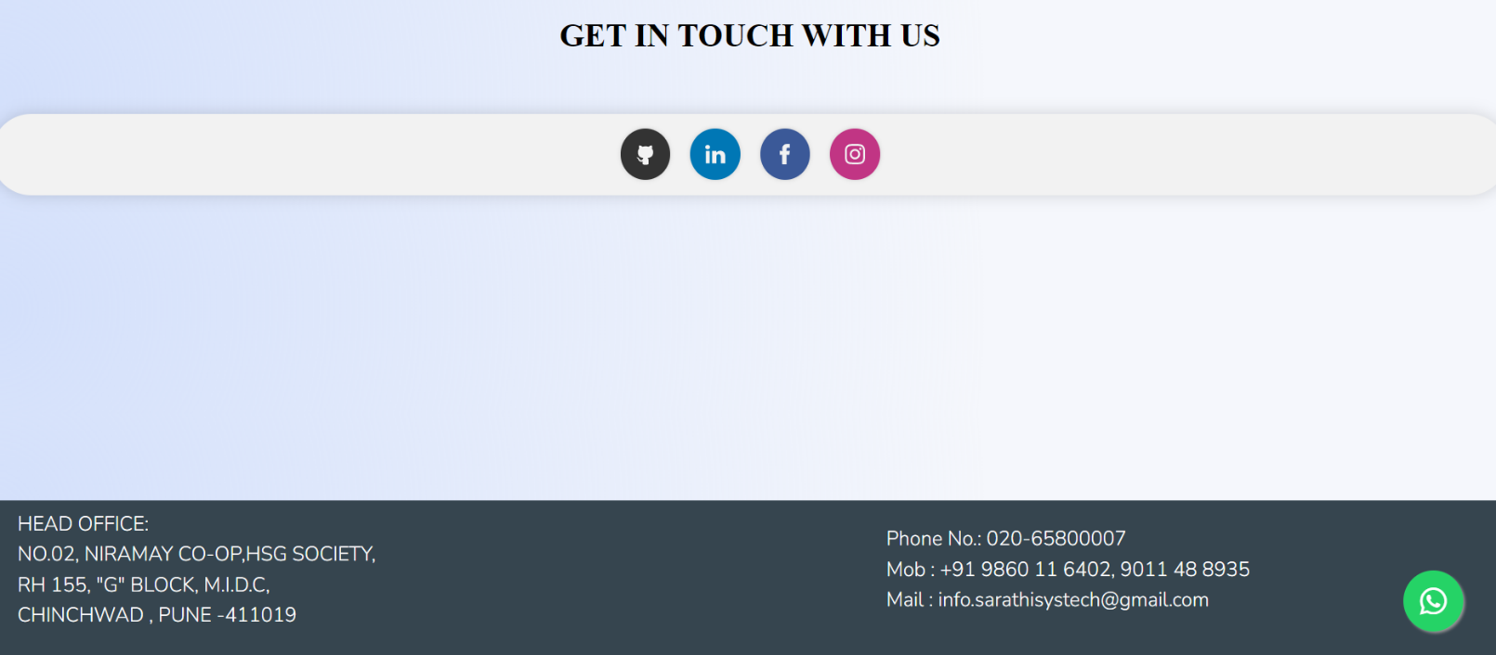

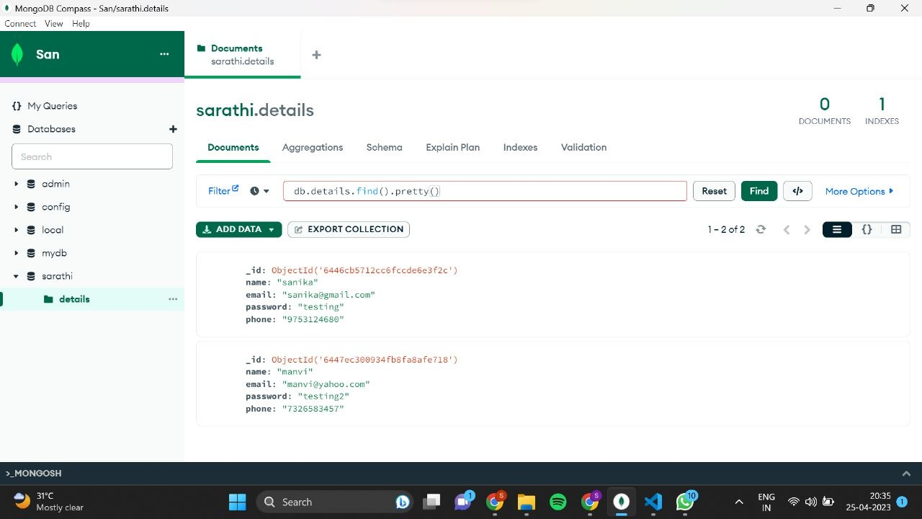

**4.2 Conclusion:**

web development enables a company to interact with its customers through various online channels such as email, social media, and chat support. This not only helps in building trust and reliability but also enhances the customer experience. A well-designed website provides detailed information about the services offered, pricing, contact information, and other essential details that clients need to know.

**4.3 Future scope:**

1. To enable automation in receiving and sending mail of required functions.
2. With the help of automation, a system can be set up to receive and categorize emails based on their content, sender, or other criteria. This can save time and effort, as manual sorting and filtering of emails can be time-consuming and prone to human error.
3. Provide a better user interface and visuals to connect the user requirements of clients.
4. Use of better database tools such as cloud services.

**4.4 References:**

1. <https://neumorphism.io/>
2. <https://developer.mozilla.org/en-US/>
3. <https://www.smashingmagazine.com/>
4. <https://www.mongodb.com/>

**Chapter 5: Internship Completion Letter**



SARATHI SYSTECH PVT LTD

**Sarathi Systech Private Limited**

Date: 01/03/2023 Amruta Shrikant Hange, Ravet, Pune-412101 9860008008

Subject: Sponsorship/Internship completion letter for Website development of company.

To whom it may concern,

This is to certify that Mr. Shashank Shivkant Birajdar, has successfully completed their internship at **Sarathi Systech Pvt. Ltd.** from 01/02/2023 to 01/03/2023. They were able to develop a responsive full-stack website for the company and delivered satisfactory output on time as per requirements. There is no pending task in relation to their work.

Wishing all the best for future endeavors.



Regards,

Mrs. Amruta Hange